Encapsulation
Definitions:
Encapsulation is the process of separating the aspects of an object into external and internal aspects. The external aspects of an object need to be visible or known , to other objects in the system. The internal aspects are details that should not affect other parts of the system. Hiding the internal aspects of an object means that they can be changed without affecting external aspects of the system.

Encapsulation means keeping actions and attributes together under a single unit. This can also be understood using a motor bike example. A bike has actions such as 'switch on light', 'horn' ‘start bike’ etc. and attributes such specific color, size, weight etc. Here the actions and attributes are bundled together under a single unit, bike.

a) Encapsulation in a Real World Elevator System
Any useful elevator has a mechanism, such as buttons, that allow a passenger to select his or her destination floor. (we have two objects here Elevator and Person ). Pressing a button is a very easy action to perform for the user of the elevator. However, for the elevator faced with many conflicting simultaneous requests from many different people, it can be a complicated matter deciding which floor to go to and fulfill the request of each traveler appropriately.
e.g Person A might enter the elevator at floor 3 and request to go to floor 30. However, another person, B, has already pressed the button on floor 1 requesting to be picked up there. If the elevator goes directly to floor 30 with person A (but without B), person A will get there as fast as he or she could ever expect. However, person B has to wait. Perhaps, by merely moving two floors down, the elevator could have taken both people to a higher floor at the same time, saving time and power. Instead, the elevator has to go all the way up to floor 30 and then back down to pick up B. With many people constantly requesting elevators and destination floors, the matter gets much more complex as far as implementation logic is concerned.
At least a couple of other aspects complicate matters further for our trusted elevator:
- Several elevators are probably working together to transport people between the different floors. They consequently need a "team" approach to fulfill as many requests as possible. Densely populated buildings with large amounts of traffic between floors require approximately two elevators for every three floors. Thus, a 60-floor building would require about 40 elevators.
- Certain floors are more likely to be visited and have pick-me-up requests than other floors. These probabilities might vary throughout the day. If the elevators can somehow remember these patterns, they can optimize the efficiency of the sequence of floors visited.
Sophisticated algorithms have been constructed running inside computers that control the movements of the elevators, allowing them to serve as many people as possible, fast and efficiently.
This was a bit of elevator talk, but it leads us to an essential observation.
It is easy for a person to press a button and thereby use the hidden complex services (algorithms, engines, gears, wires, data about current speed, maximum speed, and so on) provided by the elevator. Thus, the ignorant passenger, in terms of elevator technology, can easily utilize the services of the elevator to accomplish his or her tasks of the day.
Not only is this concealment of elevator data, algorithms, and mechanics an advantage for travelers who do not want to deal with complex matters that are irrelevant to them; but it also improves the reliability of the elevator itself. No unauthorized and incompetent person can gain access to the inner control mechanisms of the elevator. Imagine if the elevator was equipped with a small "cockpit" where anybody traveling in the elevator could tinker with the maximum speed, or make the elevator believe it was on an incorrect floor, or force it to move to a floor other than the one calculated by its control algorithms. A chaotic situation would soon prevail.
A final advantage of segregating the buttons from the underlying elevator mechanisms is the capability of making changes to these mechanisms without altering the buttons and, hence, the way it is operated. In this way, an elevator can contain the same buttons that everyone has become accustomed to using for many years, while many underlying hardware and software upgrades have taken place to keep the system up to date.

Encapsulation in an Elevator Simulation
An elevator simulation program written in will probably have Elevator and Person objects along with others. Even though now inside a computer program, a Person object will still be able to perform the equivalent of "pressing the button" of an Elevator object and giving it a floor request.
Each Elevator object of the simulation probably contains, like its real counterpart, many complex methods and many sensitive data. For example, many Elevator objects might, to make the simulation particularly realistic, be equipped with algorithms (similar to the algorithms of real world elevators) to calculate the most efficient sequence of floors visited.
Now the important analogy—each Person object (and the programmer implementing it) of the simulation should still not need or be allowed to "know" about the inner complexities (source code) of any Elevator object. All they should "care" about, just like their real counterparts, is to get from one floor to another. They don't want to be confused about unnecessary complexities either. They should not be allowed to tinker with the inner workings (data and source code) of the Elevator object, and the programmers implementing the elevator should be able to change and upgrade the source code without interfering with how the Elevator object is used (operated).
To accomplish this concealment in the OO world, we say that we encapsulate (hide) the underlying data and source code that is irrelevant for all but the Elevator objects themselves.
A Person object needs somehow the ability to "express" its floor request. A method with this capacity could arbitrarily be called NewFloorRequest which should be a public method in Elevator. The Elevator object, like its real counterpart, might need to somehow keep track of, for example, the speed at which it is traveling and its maximum speed; these are the instance variables (data) of the object, as mentioned previously. The Elevator object does not want any interference from other objects to mistakenly change their instance variables. Therefore, the Elevator objects declare them to be private, making them inaccessible for other objects.

b) an automated voice-mail system, we should be able to change the component that handles storing the messages without affecting other parts of the system. For example, we might want to increase the number of messages that a user can store. If the message-storing system has been properly hidden and isolated, this change should not affect how users access the system and leave or retrieve messages.
c) How coffee vending machine works ?
You dropped in the coin, and the coffee came out of the machine in a beautiful coffee cup. So, why didn’t you see how the where the coffee beans, how it is prepared? You really don’t know (unless you are the one who designed the machine) how things are made inside the machine, but finally you get a coffee!! Here don’t you see a sense of Encapsulation? So, here what is actually hidden is , the way how the coffee prepared .
So, Encapsulation is hiding of process; hence you hide the data. Not the vice versa.
From the definition, Encapsulation is “Information Hiding”, the information is how something is happening inside an object? It’s just a mere data hiding concept (though it includes data hiding).
So, when you model this coffee vending machine, you don’t want to show out the way how a coffee is made. So, you don’t want to show where the coffee beans, milk and the sugar are !
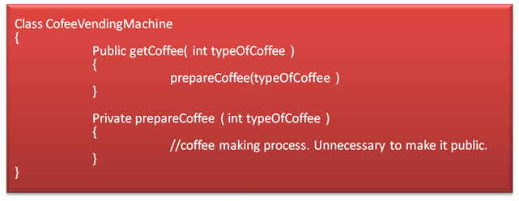
So, in the CofeeVendingMachine class, prepareCoffee() is hidden and getCoffee() is made public, so that you will be able to send a request to the machine.
Since you have hidden the process, you don’t have any need to show how the coffee & milk are mixed and how it’s been brewed.
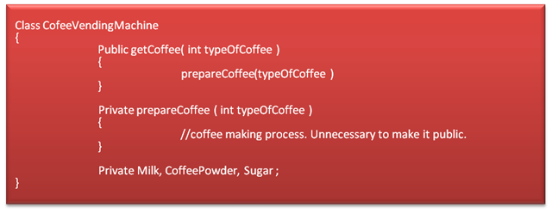
The Coffee Vending Machine encapsulates the internal process and the ingredients (data) used in the process.

